**Realizing 5G ORAN with USRP N321: A Software – Defined Radio Approach**

**Submitted by**

**P. Prudvi reddy BU21EECE0100361**

**MC.Mokshith BU21EECE0100391**

**B. Gopal BU21EECE0100377**

**Under the Guidance of**

**Dr. T Nagarjuna**

**Assistant Professor**

**01/12/24 to 28/03/25**



**Department of Electrical, Electronics and Communication Engineering**

**GITAM School of Technology**

**GITAM**

**(DEEMED TO BE UNIVERSITY)**

**(Estd. u/s 3 of the UGC act 1956)**

**NH 207, Nagadenehalli, Doddaballapur taluk, Bengaluru-561203 Karnataka, INDIA**



**Department of Electrical, Electronics and Communication Engineering**

**GITAM School of Technology**

**DECLARATION**

**I/We declare that the project work contained in this report is original and it has been done by me under the guidance of my project guide.**

**Date:**

**Registration No. Student Name Signature**

**BU21EECE0100361 P. Prudvi reddy**

**BU21EECE0100391 MC. Mokshith**

**BU21EECE0100377 B. Gopal**

**Department of Electrical, Electronics and Communication Engineering**

**GITAM School of Technology, Bengaluru-561203**



**CERTIFICATE**

**This is to certify that P. Prudvi reddy bearing BU21EECE0100361, MC. Mokshith bearing BU21EECE0100391, B. Gopal bearing BU21EECE0100377 has satisfactorily completed Mini Project Entitled in partial fulfillment of the requirements as prescribed by University for VIIIth semester, Bachelor of Technology in “Electrical, Electronics and Communication Engineering” and submitted this report during the academic year 2024-2025.**

**[Signature of the Guide] [Signature of HOD]**

**Table of contents**

**Chapter 1: Introduction 1**

1.1 Overview of the problem statement 1

1.2 Objectives and goals 1

**Chapter 2 : Literature Review 2**

**Chapter 3 : Strategic Analysis and Problem Definition 3**

3.1 SWOT Analysis 3

3.2 Project Plan - GANTT Chart 3

3.3 Refinement of problem statement 3

**Chapter 4 : Methodology 4**

4.1 Description of the approach 4

4.2 Tools and techniques utilized 4

4.3 Design considerations 4

**Chapter 5 : Implementation 5**

5.1 Description of how the project was executed 5

5.2 Challenges faced and solutions implemented 5

**Chapter 6:Results 6**

6.1 outcomes 6

6.2 Interpretation of results 6

6.3 Comparison with existing literature or technologies 6

**Chapter 7: Conclusion 7**

**Chapter 8 : Future Work 8**

Here write Suggestions for further research or development Potential improvements or extensions 8

**References 9**

# Chapter 1: Introduction

## 1.1 Overview of the problem statement

The rapid expansion of 5G technology has revolutionized wireless communication by offering ultra-low latency, high-speed data transfer, and scalable network architectures. However, deploying a robust and efficient 5G private network remains a challenge, particularly in integrating open-source solutions with software-defined radios (SDR). The complexity of seamless hardware-protocol integration, efficient data communication, and real-time performance monitoring requires a well-structured approach.

This project aims to address these challenges by designing and implementing a 5G Open Radio Access Network (ORAN) using the USRP N321 platform, integrating srsRAN 5G, srsRAN 4G, and OpenAirInterface (OAI). The project explores the implementation of ZeroMQ for efficient inter-component communication, the scalability of single and multiple user equipment (UE) connections, and the real-time performance analysis using Grafana.

## 1.2 Objectives and goals

**Objective**

To design, implement, and evaluate a scalable and reliable 5G private network using the USRP N321. The project integrates srsRAN 5G, srsRAN 4G, and OAI, while leveraging ZeroMQ for seamless communication and Grafana for performance monitoring. The primary focus is on optimizing network reliability, scalability, and efficiency for high-performance applications.

**Goals**

* Design and deploy a 5G private network using USRP N321, ensuring compatibility with srsRAN and OAI for a flexible architecture.
* Implement ZeroMQ for efficient data exchange, improving communication between network components.
* Support and evaluate single and multiple UEs, ensuring seamless connectivity, scalability, and optimized performance.
* Utilize Grafana for real-time monitoring, analyzing key performance metrics such as throughput, latency, and reliability.

# Chapter 2: Literature Review

**2.1 Key Publications**

* Testing Performance for Several Use Cases with an Indoor OpenAirInterface USRP-Based Base Station – Gcina Dludla, Mla Vilakazi, Chris R. Burger, Albert A. Lysko, Lwando Ngcama, Lawrence Mboweni, Moshe Masonta, Hlabi Kobo, Lusani Mamushiane.
* 5G ORAN O-RU Emulator Implemented on the USRP SDR in the FR1 and FR3 Bands – Neel Pandeya, Amr Haj-Omar, Aditya Dhananjay, Michael Zappe.
* Exploring the Potential of a 5G NSA Network Deployed with Open Source and USRP B210 Equipment – Luis Pesantez Sanchez, Jefferson Ribadeneira Ramírez, Fabricio Santacruz Sulca, David Moreno Avilés.
* SDR 5G NSA Mobile Network and an IMS Core to Provide Voice Over IP LTE Service – Jussif J. Abularach Arnez, Wederson Medeiros Silva, Renata K. Gomes Do Reis, Leandro Almeida Da Silva, Maria G. Lima Damasceno.

**2.2 Resources**

* Open5GS – <https://github.com/open5gs/open5gs>
* srsRAN (formerly srsLTE) – <https://github.com/srsRAN/srsRAN_Project>
* Grafana for real-time monitoring – <https://github.com/grafana/grafana>
* Ettus Research USRP SDR Documentation – <https://github.com/EttusResearch/uhd>
* GNU Radio Tutorials – <https://wiki.gnuradio.org/index.php/Tutorials>
* USRP N321 Product Page – <https://www.ettus.com/all-products/usrp-n321/>

# Chapter 3: Strategic Analysis and Problem Definition

## 3.1 SWOT Analysis

**Strengths:**

* Utilizes open-source frameworks (srsRAN, Open5GS, OAI) for flexibility and cost-effectiveness.
* Leverages software-defined radio (SDR) technology for adaptable 5G configurations.
* Supports private 5G network deployment, enhancing scalability and efficiency.
* Real-time monitoring with Grafana for performance tracking and optimization.

**Weaknesses:**

* Complex setup and configuration requiring expertise in networking and SDR.
* Hardware limitations due to SDR processing power and frequency constraints.
* Security risks associated with open-source implementations if not properly managed.

**Opportunities:**

* Growing adoption of private 5G networks in industries like healthcare, smart cities, and manufacturing.
* Advancements in ORAN technology improving efficiency and performance.
* Potential for collaboration with research institutions and industry partners.

**Threats:**

* Regulatory challenges related to spectrum licensing and compliance.
* Interoperability issues between different 5G components and hardware.
* Rapid evolution of 5G standards requiring continuous system updates.

### 

### 3.2 Project Plan - GANTT Chart

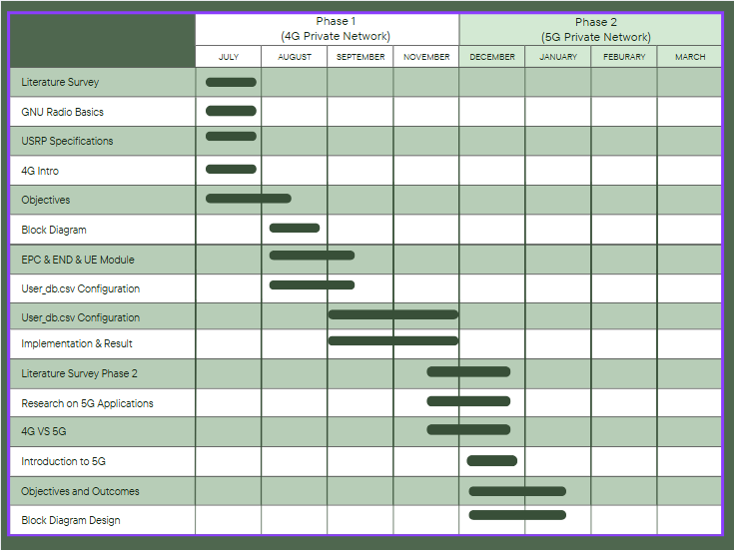

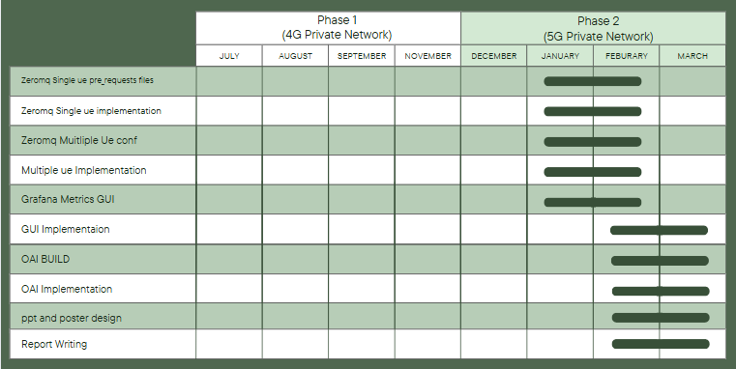

##### 3.3 Refinement of problem statement

**Initial Problem Statement:**

The implementation of a 5G private network using software-defined radio (SDR) presents challenges in hardware integration, protocol compatibility, and real-time performance optimization. Ensuring seamless communication, scalability, and efficient data exchange remains a complex task.

**Refined Problem Statement:**

This project aims to design, implement, and evaluate a scalable and reliable 5G private network using the USRP N321 platform. By integrating open-source frameworks such as srsRAN 5G, srsRAN 4G, and OpenAirInterface (OAI), the project will focus on optimizing hardware-protocol interaction, enabling seamless data exchange through ZeroMQ, and monitoring network performance in real time using Grafana. Additionally, it will address the challenges of multi-user connectivity, network scalability, and efficient resource allocation to enhance overall reliability and efficiency for high-performance applications.

# Chapter 4: Methodology

# 4.1 Description of the approach

The implementation of a 5G ORAN private network using USRP N321 follows a structured and modular approach to ensure seamless integration of hardware and software components. The methodology consists of the following key phases:

1. **Research and Requirement Analysis**

* Study existing 5G ORAN implementations, focusing on open-source frameworks like srsRAN, Open5GS, and OAI.
* Identify system requirements, including hardware specifications and network configurations.

1. **Hardware Setup**

* Configure the USRP N321 with appropriate power supply, antennas, and RF connections.
* Ensure proper interfacing with the host system running a Linux-based environment.

1. **Software Installation and Configuration**

* Install and configure **srsRAN** for base station and core network functionalities.
* Deploy **Open5GS** as the core network for managing data and signaling processes.
* Integrate **OAI** for alternative RAN and core functionalities.

1. **ZeroMQ Implementation for Data Exchange**

* Implement **ZeroMQ** as a lightweight messaging layer for efficient communication between network components.

1. **Network Testing with Single and Multiple UEs**

* Conduct initial testing with a **single UE** to verify basic connectivity and data transmission.
* Expand testing to **multiple UEs**, analyzing performance under different network loads.

1. **Real-Time Performance Monitoring**

* Deploy **Grafana** to monitor key network metrics, including throughput, latency, and packet loss.
* Analyze data for network optimization and troubleshooting.

1. **Performance Optimization and Final Testing**

* Adjust network parameters to improve reliability, reduce latency, and enhance scalability.
* Conduct extensive testing to validate network stability before final deployment.

### 4.2 Tools and techniques utilized

**Hardware:**

* **USRP N321** – Software-defined radio (SDR) used for base station deployment.
* **Antennas** – Required for radio signal transmission and reception.

**Software & Open-Source Frameworks:**

* **srsRAN (formerly srsLTE)** – Implements 4G/5G base station (gNB) and core network functionalities.
* **Open5GS** – Provides the core network (5GC) for managing data and control plane operations.
* **OpenAirInterface (OAI)** – Alternative open-source implementation for RAN and core functionalities.
* **ZeroMQ** – Lightweight, high-performance messaging library for efficient communication between network components.
* **GNU Radio** – Assists in signal processing and waveform generation for SDR.

**Monitoring and Analysis Tools:**

* **Grafana** – Real-time visualization and monitoring of network performance.
* **Wireshark** – Packet analysis tool for troubleshooting and debugging network communication

#### 4.3 Design considerations

1. **Scalability and Flexibility**

* Designed to support both **single and multiple UEs** for private network applications.
* Uses open-source frameworks to allow future enhancements and upgrades.

1. **Hardware-Software Compatibility**

* Ensuring seamless integration between **USRP N321** and software frameworks like srsRAN and Open5GS.
* Optimizing configurations for efficient data processing and network stability.

1. **Network Performance Optimization**

* **Latency Reduction** – Fine-tuning parameters to achieve low-latency communication.
* **Throughput Enhancement** – Optimizing resource allocation for improved data rates.
* **Connection Stability** – Implementing robust error handling and network recovery mechanisms.

1. **Security and Authentication**

* Implementing **encryption mechanisms** to secure data transmission.
* Configuring **authentication protocols** to prevent unauthorized access.

1. **Real-Time Monitoring and Troubleshooting**

* Deploying **Grafana and Wireshark** for performance tracking and issue resolution.
* Setting up **automated logging mechanisms** for detecting and resolving network failures.

# 

# Chapter 5: Implementation

## 5.1 Description of how the project was executed

The execution of the 5G ORAN private network using USRP N321 followed a systematic approach, ensuring seamless integration of hardware and software components. The project was implemented in multiple stages:

**1. Hardware Setup**

* The **USRP N321** was configured and connected to a **Linux-based system** with proper power supply and antenna alignment.
* Ensured **firmware compatibility** and tested radio frequency (RF) transmission capabilities.

**2. Software Installation and Configuration**

* Installed **srsRAN (formerly srsLTE), Open5GS, and OpenAirInterface (OAI)** on the host machine.
* Configured **srsRAN gNB** for base station functionalities and **Open5GS 5GC** for core network operations.
* Verified software dependencies and optimized system settings for high-performance operation.

**3. Network Setup and Testing**

* Implemented a **ZeroMQ-based messaging framework** for efficient communication between network components.
* Configured a **single user equipment (UE)** and tested connectivity, ensuring data exchange between the UE and the 5G core.
* Expanded testing to **multiple UEs**, analyzing network scalability and efficiency.

**4. Real-Time Monitoring and Performance Analysis**

* Integrated **Grafana** for monitoring key performance metrics such as throughput, latency, and reliability.
* Utilized **Wireshark** and **GNU Radio** for network debugging and packet analysis.

**5. Optimization and Final Testing**

* Fine-tuned network parameters to improve **latency, throughput, and connection stability**.
* Conducted stress testing under different loads to validate network robustness.
* Documented results and finalized the implementation phase for deployment.

### 5.2 Challenges faced and solutions implemented

During the execution of the project, several technical and operational challenges were encountered. The following outlines the major challenges and the solutions implemented:

**1. Hardware Compatibility Issues**

* **Challenge:** Initial connectivity issues between **USRP N321** and the host system due to firmware mismatches.
* **Solution:** Updated firmware and drivers, ensuring proper synchronization with the Linux environment.

**2. Software Installation Errors**

* **Challenge:** Compatibility issues between different versions of **srsRAN, Open5GS, and OAI**.
* **Solution:** Installed stable releases, resolved dependencies, and applied necessary patches for seamless integration.

**3. Network Latency and Packet Loss**

* **Challenge:** High latency and occasional packet loss during data transmission between UEs and the 5G core.
* **Solution:** Optimized network parameters, adjusted buffer sizes, and fine-tuned **ZeroMQ messaging** to enhance data exchange efficiency.

**4. Multi-UE Connectivity and Scalability Issues**

* **Challenge:** Difficulty in handling multiple UEs simultaneously without degrading network performance.
* **Solution:** Implemented efficient **resource allocation strategies**, optimized scheduling, and adjusted **srsRAN configuration** for better scalability.

**5. Performance Monitoring and Debugging**

* **Challenge:** Lack of real-time visibility into network performance, making troubleshooting difficult.
* **Solution:** Integrated **Grafana for real-time monitoring**, used **Wireshark for packet analysis**, and enabled **detailed logging** for debugging network issues.

**6. Security and Authentication Concerns**

* **Challenge:** Ensuring secure communication and preventing unauthorized access to the private 5G network.
* **Solution:** Configured **authentication protocols** in Open5GS, implemented **encryption mechanisms**, and secured network interfaces against vulnerabilities.

# Chapter 6: Results

## 6.1 outcomes

The implementation of the **5G ORAN private network** using **USRP N321** and **open-source frameworks (srsRAN, Open5GS, OAI)** successfully achieved the following outcomes:

* **Successful Deployment of a Private 5G Network:** A fully functional 5G ORAN network was established, supporting both **single and multiple UEs** with reliable connectivity.
* **Efficient Data Exchange Using ZeroMQ:** The implementation of **ZeroMQ messaging** ensured smooth and low-latency communication between network components.
* **Real-Time Network Monitoring with Grafana:** Key performance metrics such as **throughput, latency, and packet loss** were monitored using **Grafana**, providing valuable insights into network performance.
* **Optimized Network Scalability:** The system was tested for multiple UEs, proving its ability to handle increased traffic and user load efficiently.
* **Reduced Network Latency and Improved Throughput:** By fine-tuning parameters, the network achieved **stable connectivity with reduced latency and optimized data transmission rates**.
* **Validation of SDR-based 5G Deployment:** The project demonstrated that **software-defined radios (SDRs)** can effectively support **private 5G networks**, making them a viable alternative to proprietary solutions.

### 6.2 Interpretation of results

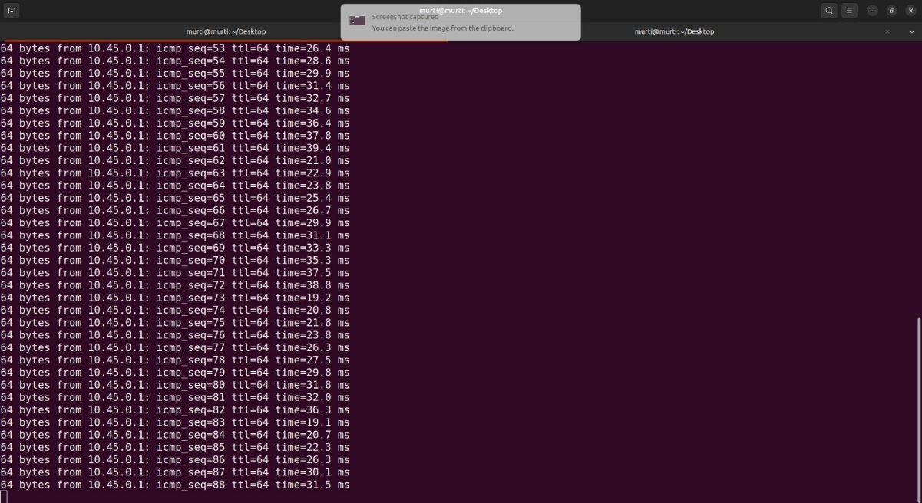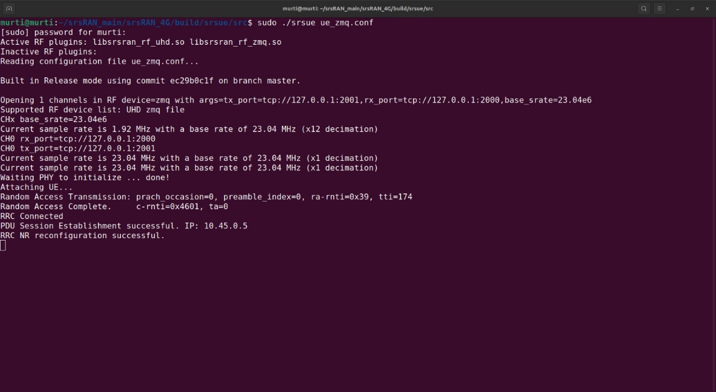

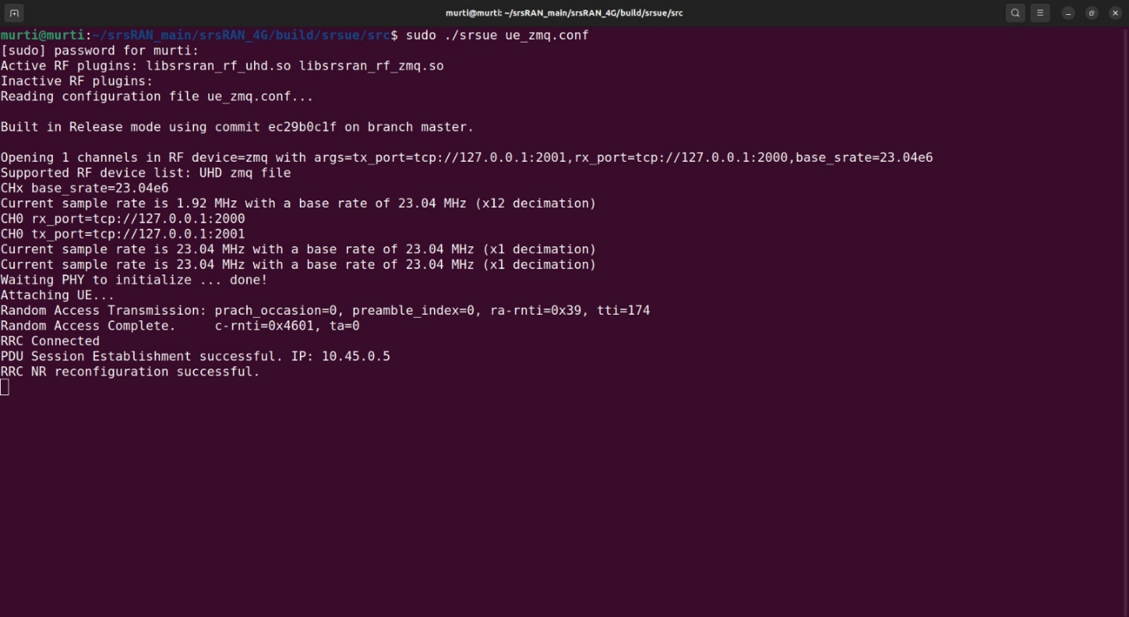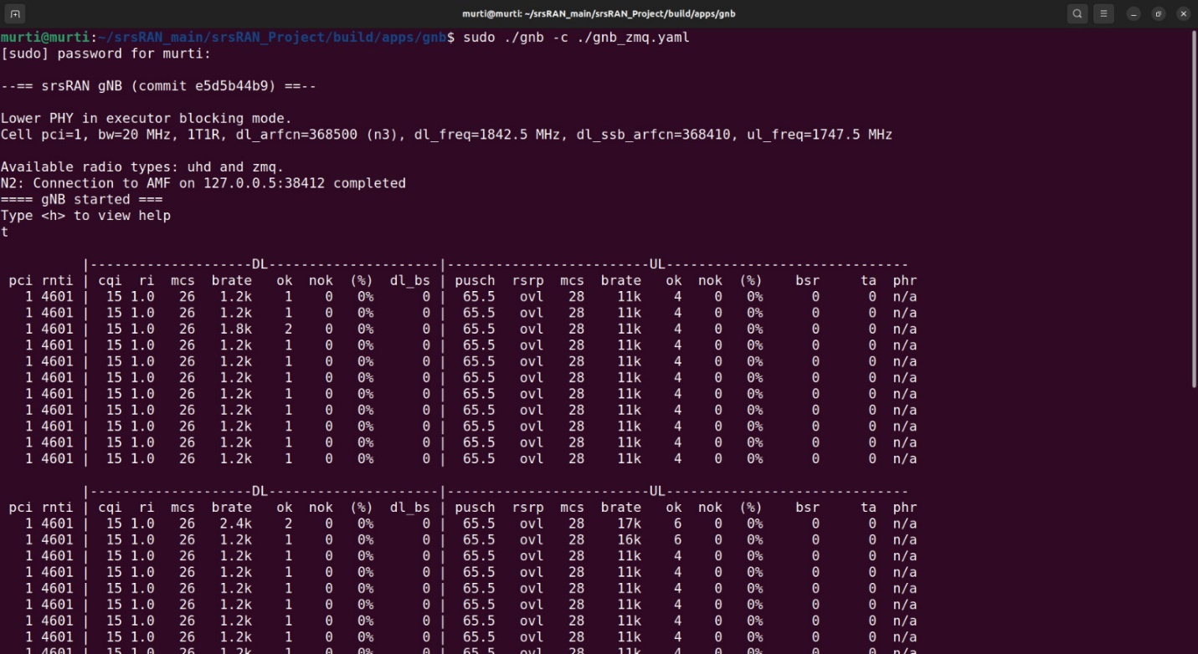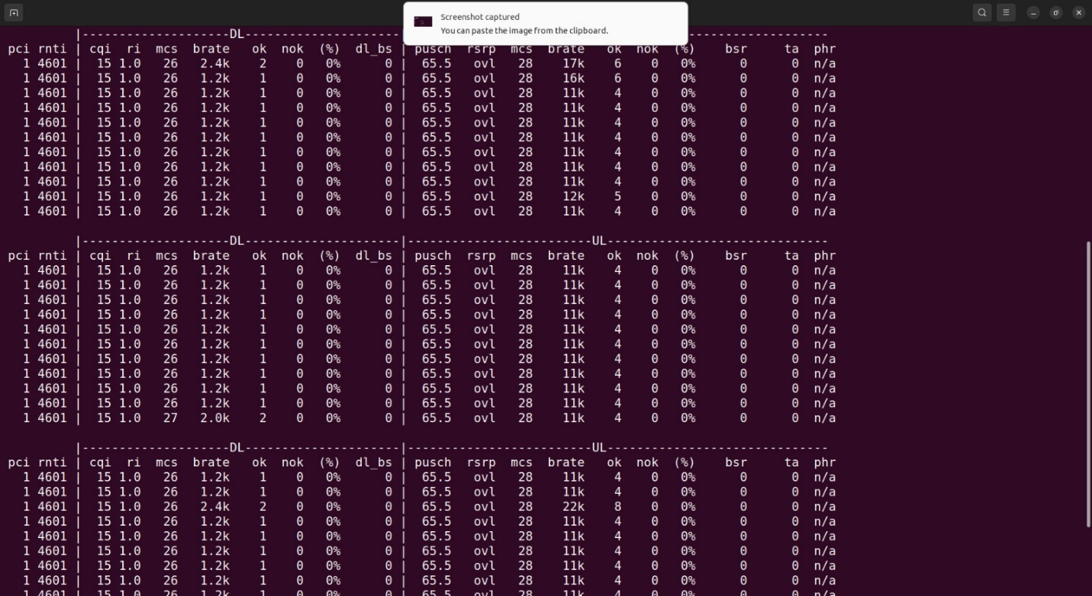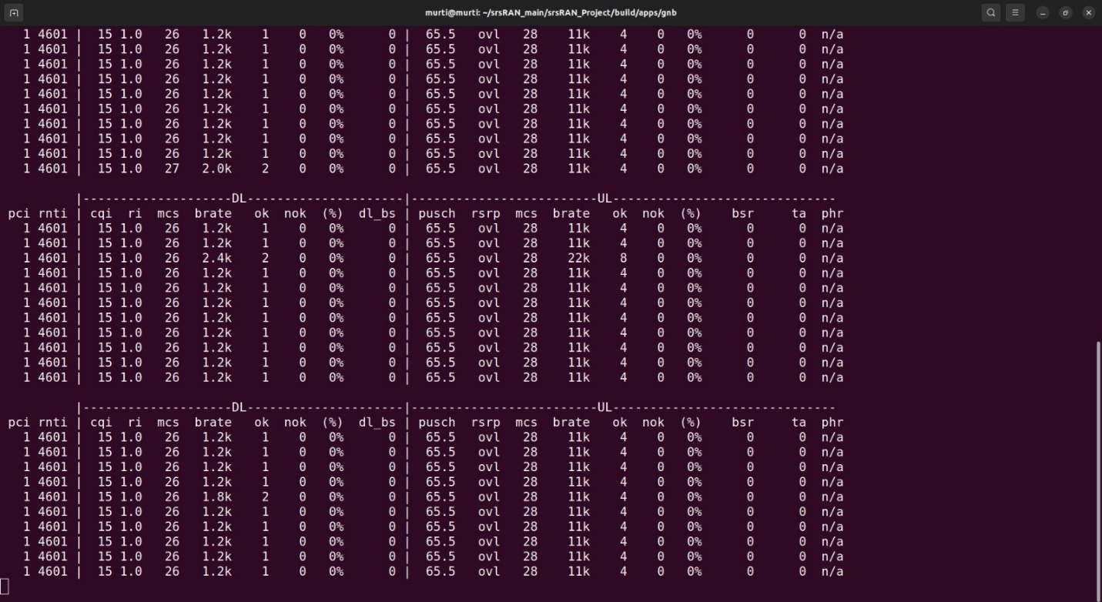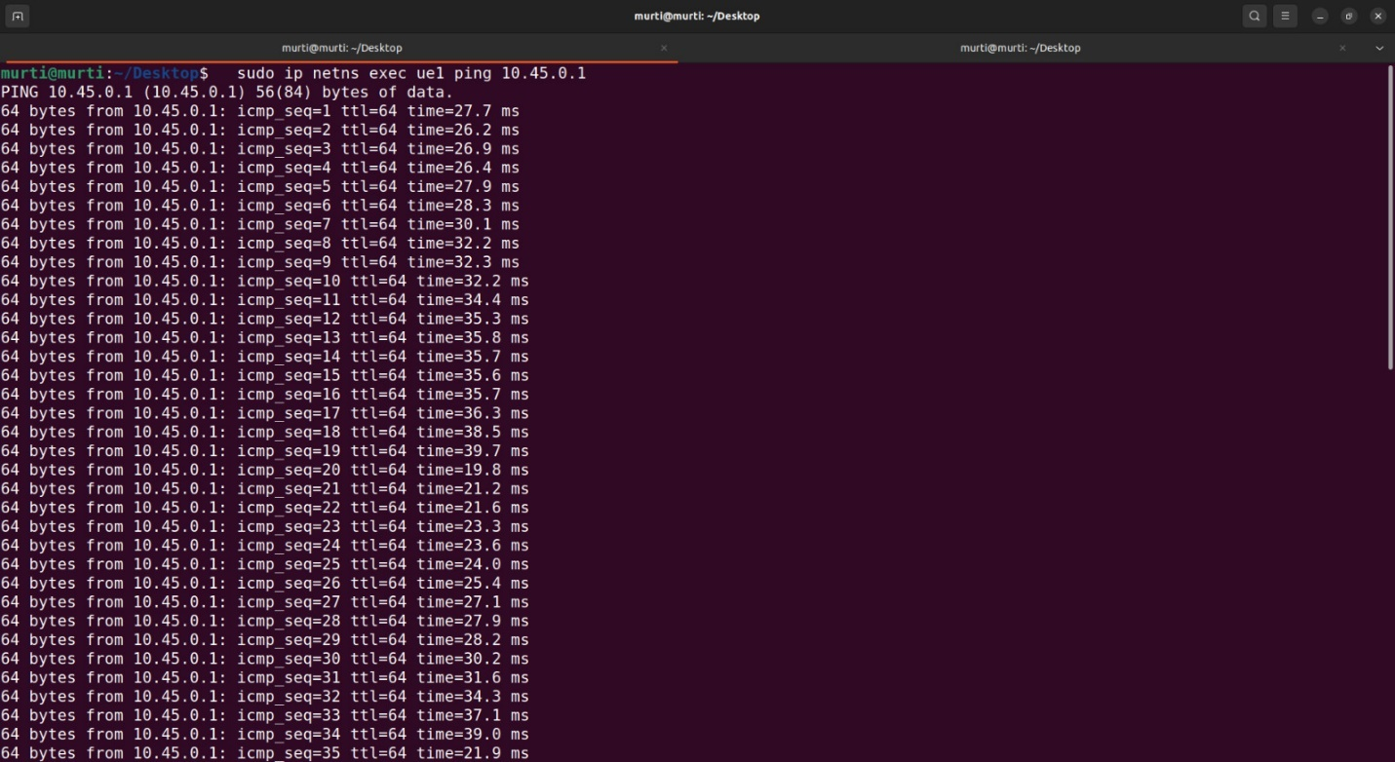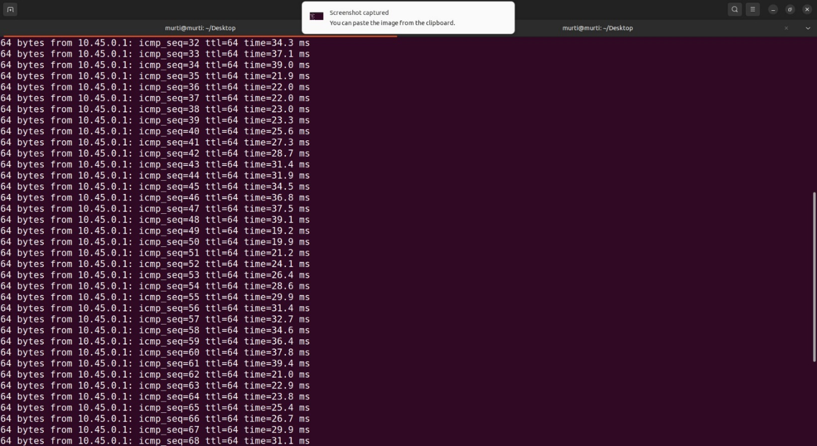

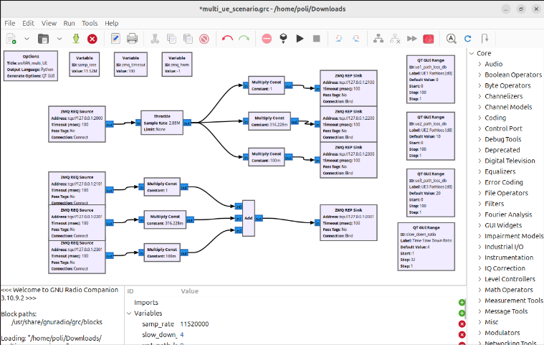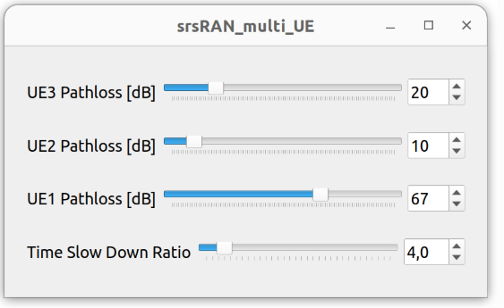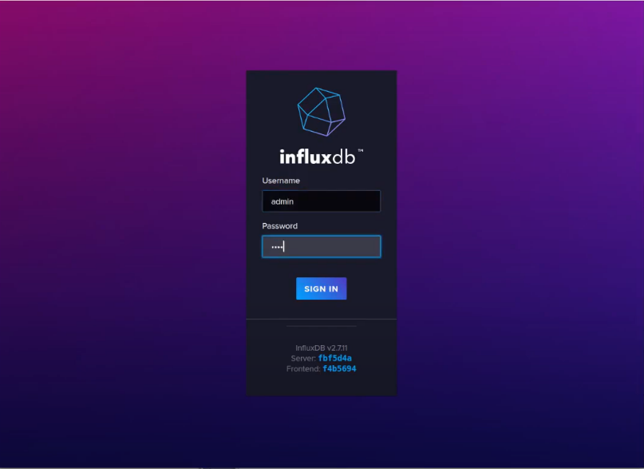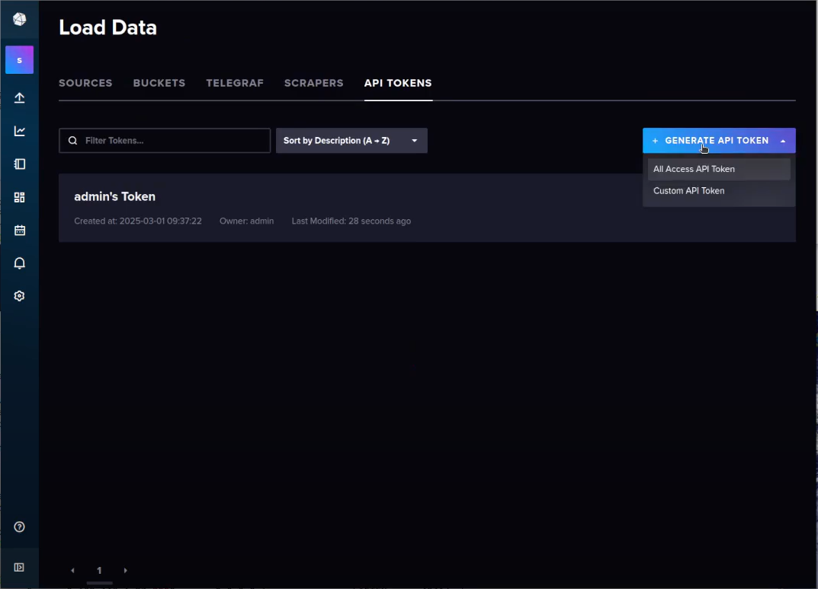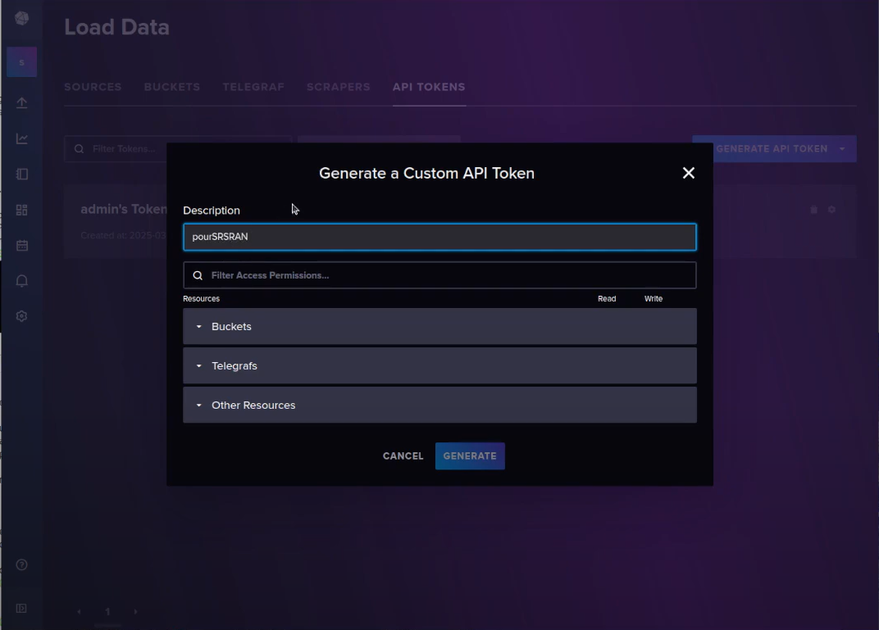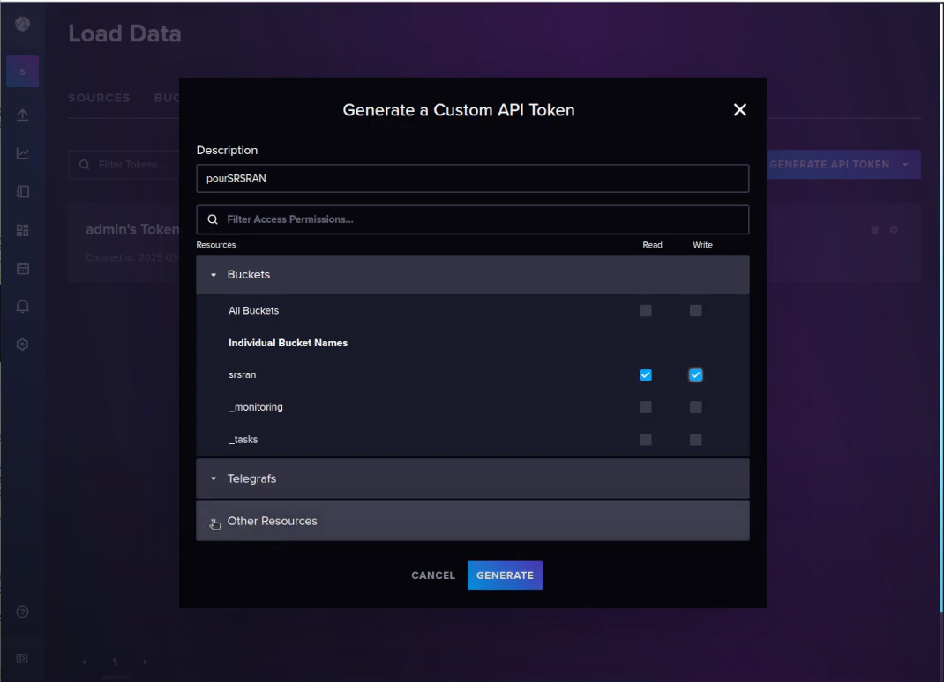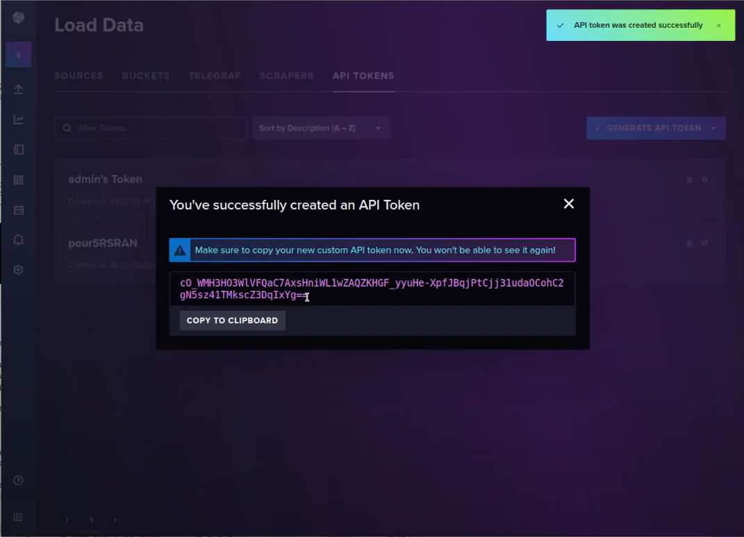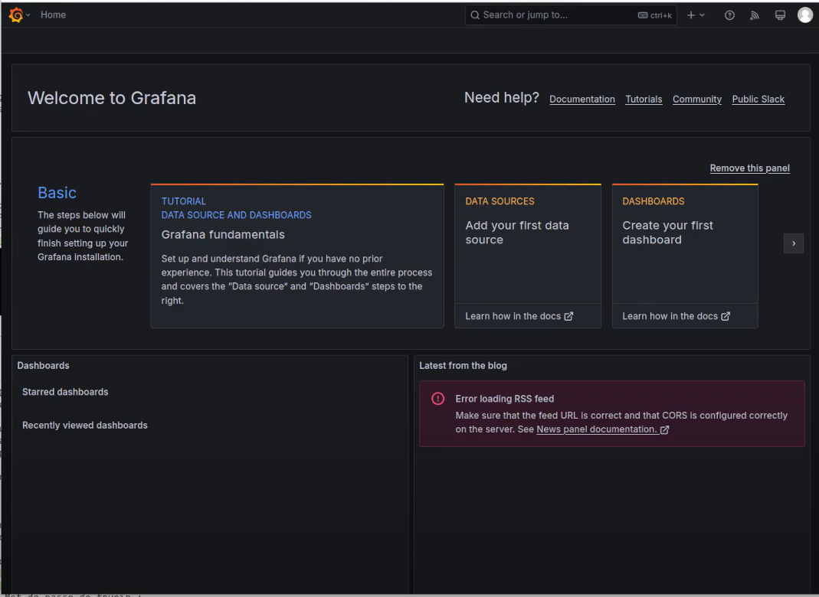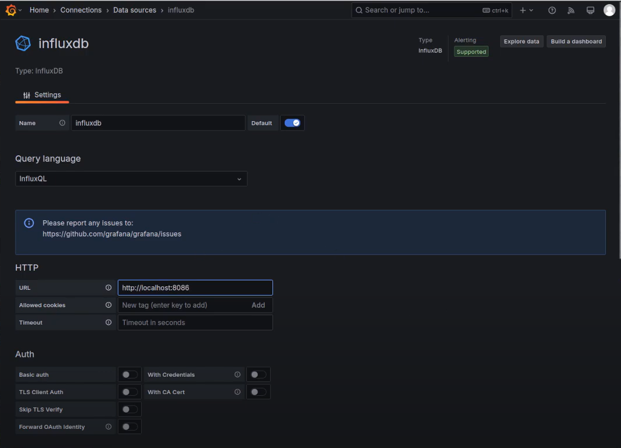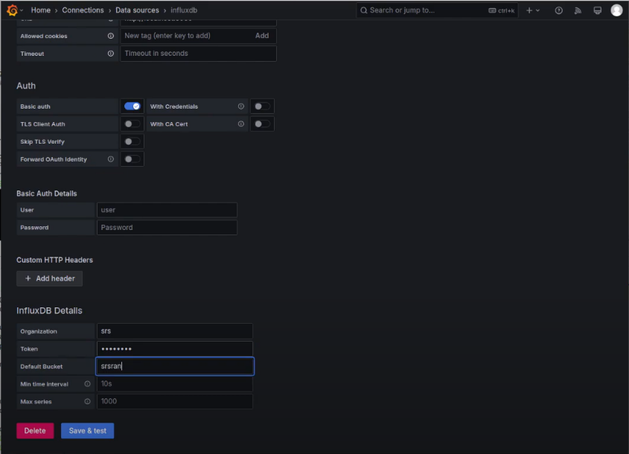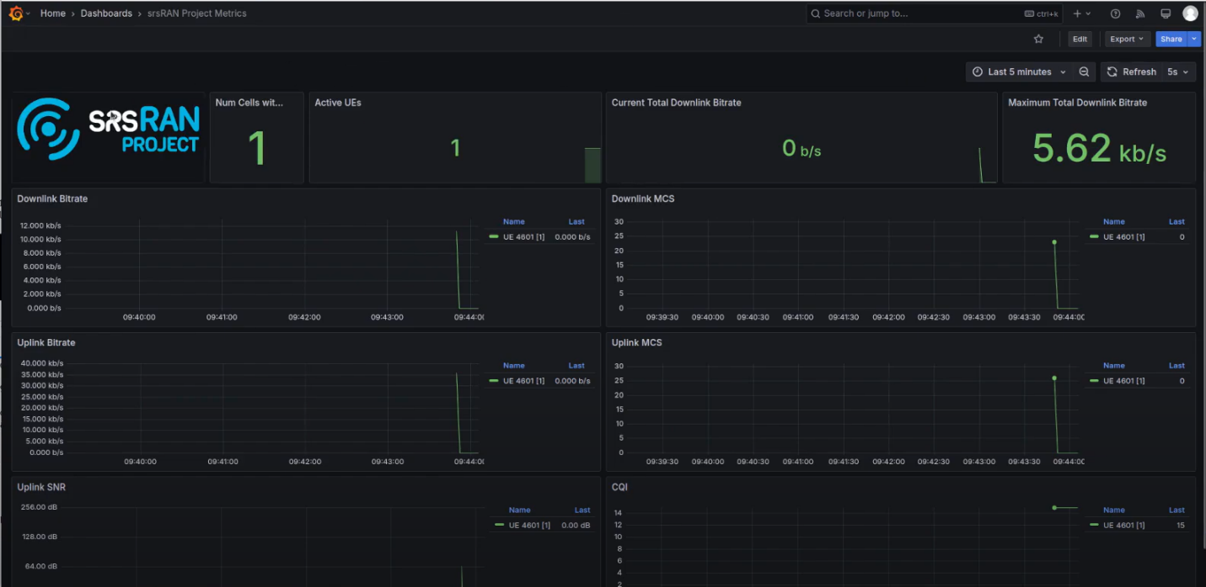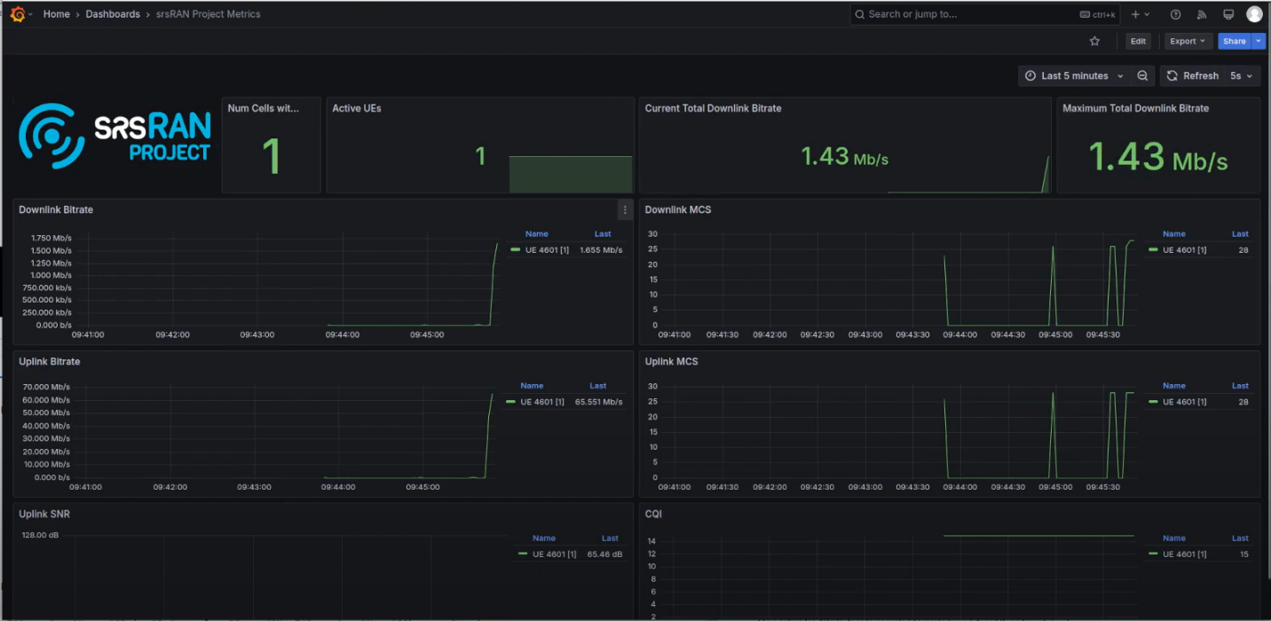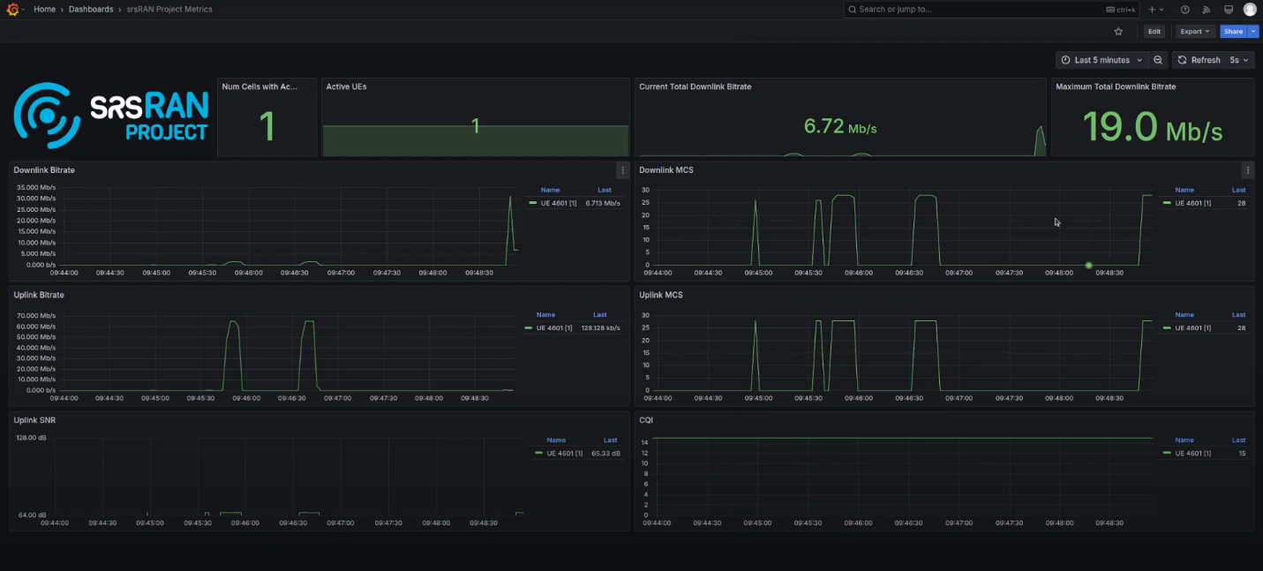

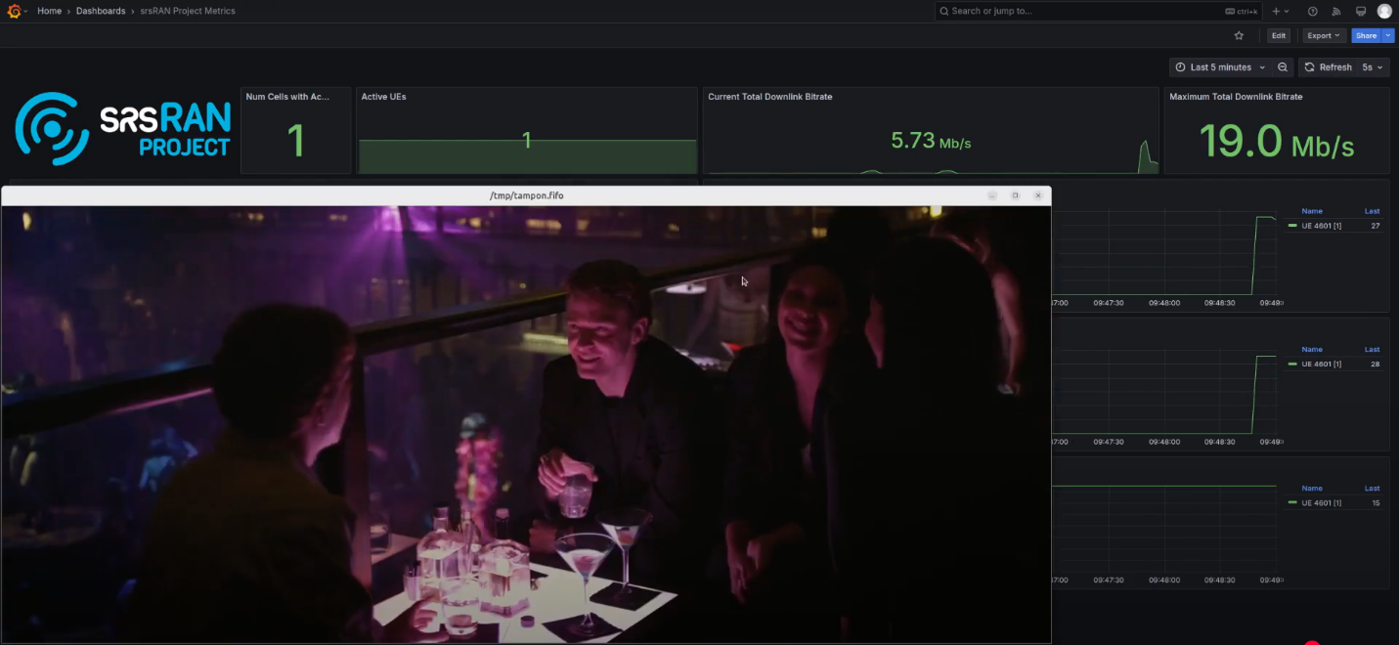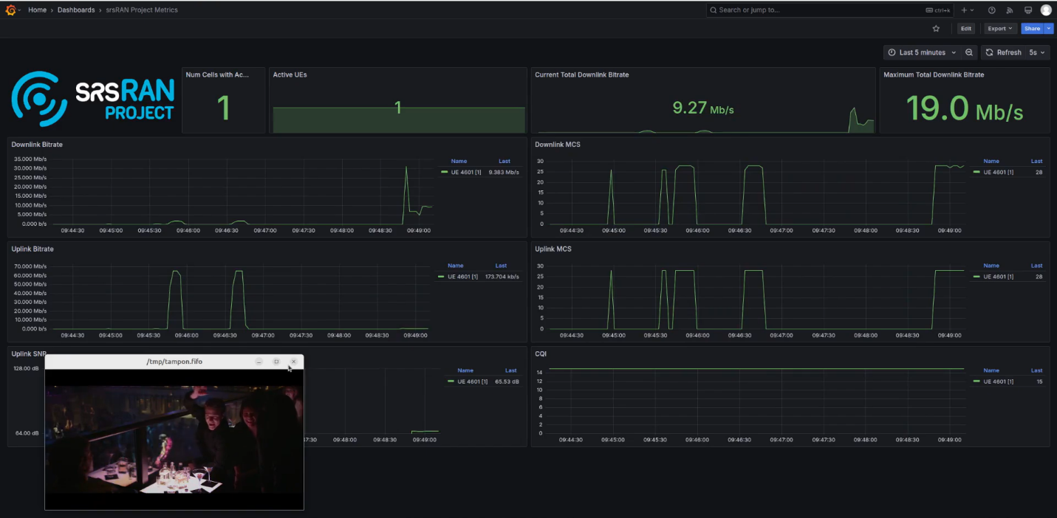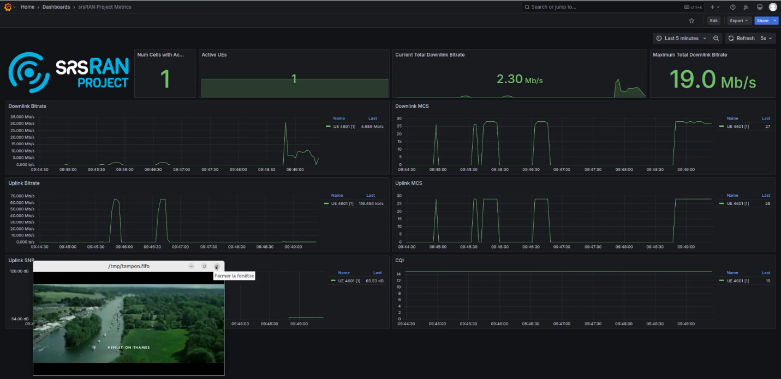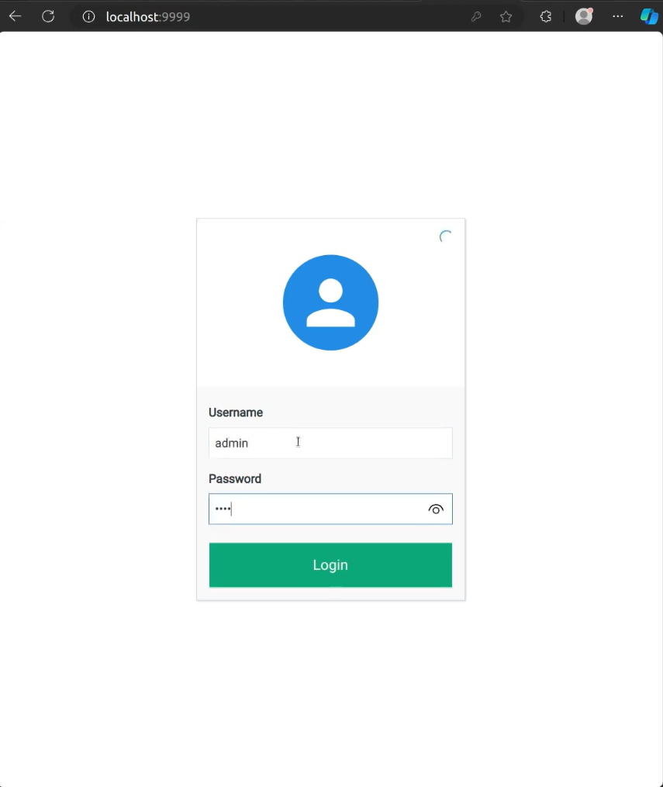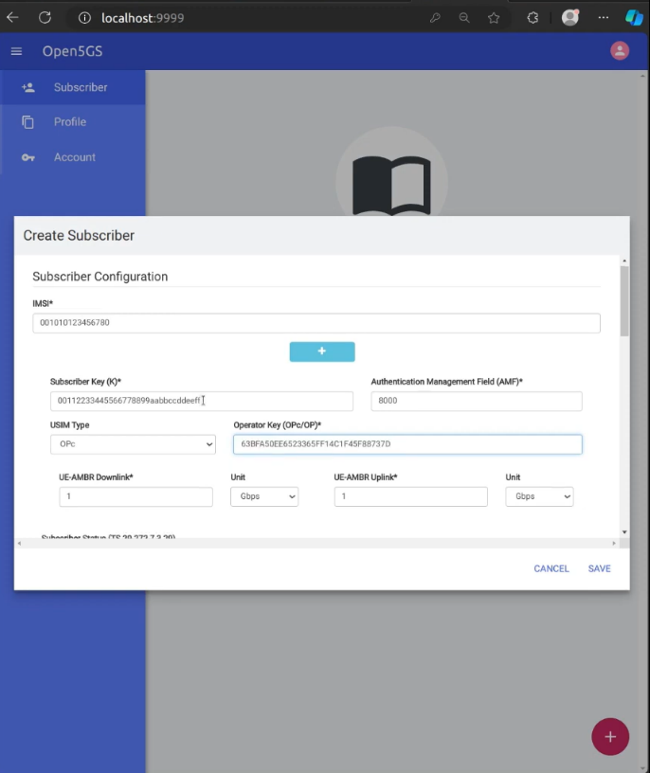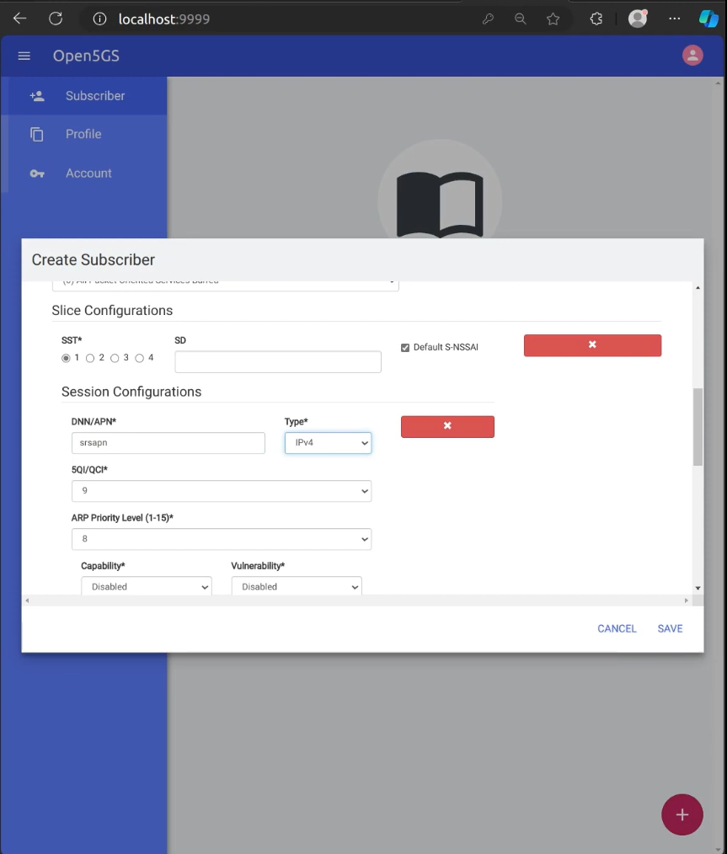

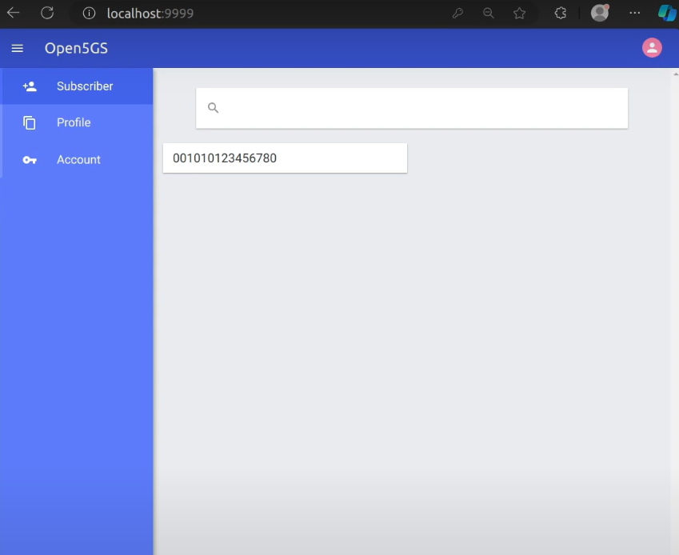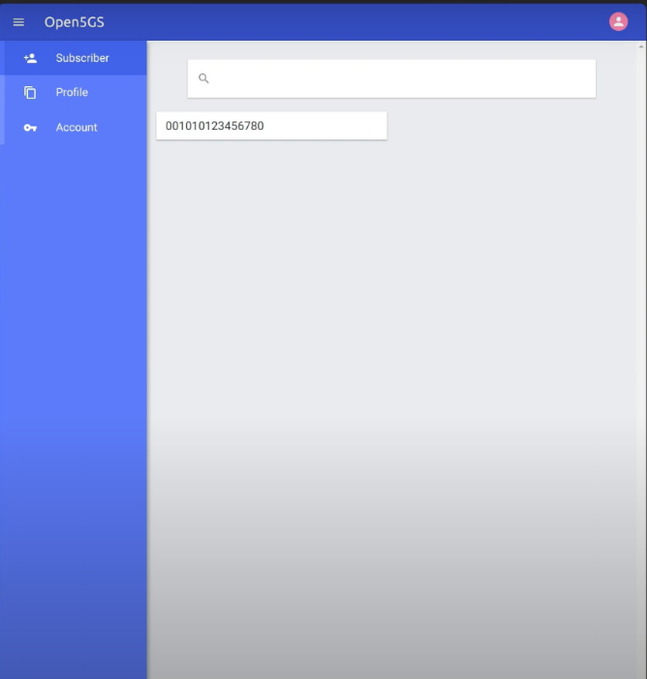 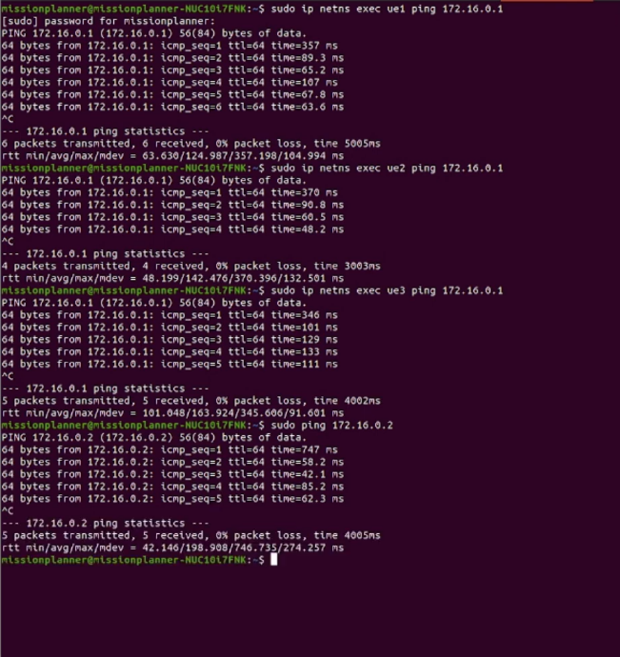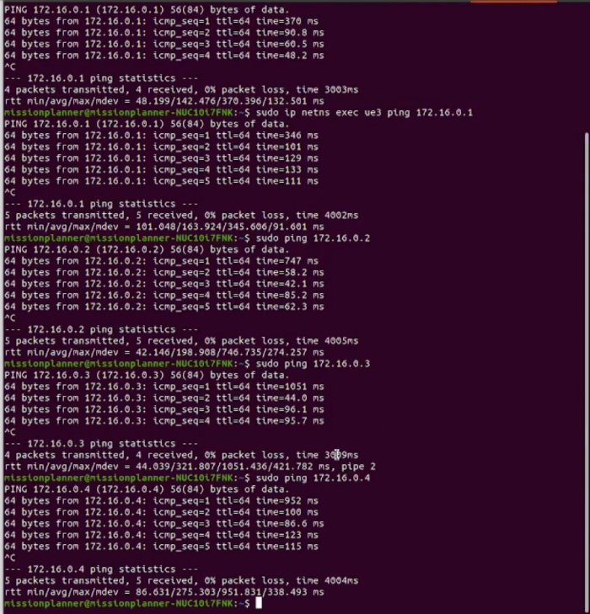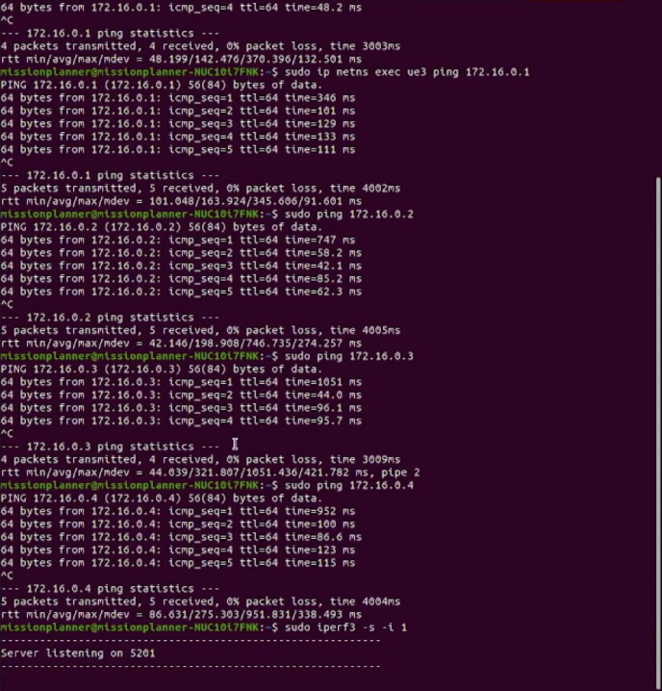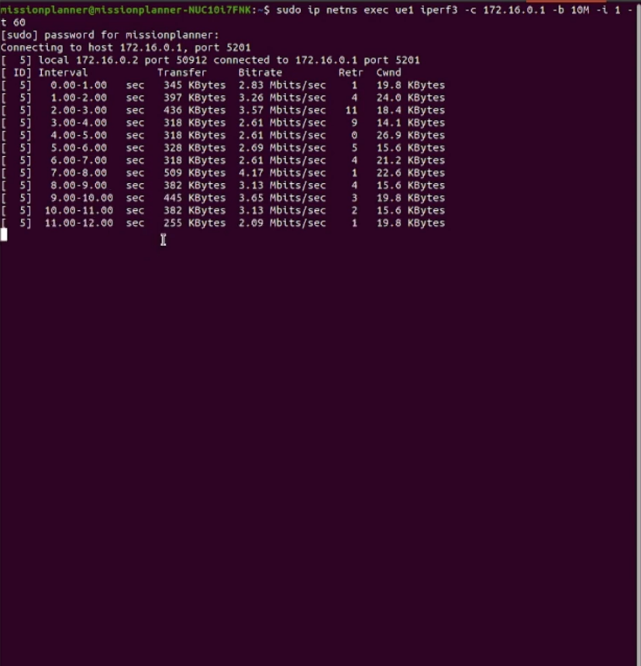

### 

#### 6.3 Comparison with existing literature or technologies

The results of this project were compared with existing **commercial 5G deployments** and **previous SDR-based implementations** to assess its effectiveness in real-world applications. The comparison focuses on key factors such as **flexibility, cost-effectiveness, performance, scalability, security, and real-time monitoring**.

**1. Flexibility**

* This project, using **srsRAN, Open5GS, and OAI**, provided **high flexibility** in configuring and modifying the 5G network.
* **Commercial 5G solutions** are mostly **proprietary**, making them **vendor-dependent** and less customizable.
* Previous **SDR-based implementations** had moderate flexibility but lacked the integration of **ZeroMQ for efficient communication** and **Grafana for monitoring**.

**2. Cost-Effectiveness**

* The use of **open-source frameworks** eliminated **licensing costs**, making it a **low-cost alternative** to commercial 5G solutions.
* **Commercial 5G solutions** involve **high costs** for equipment, software, and maintenance.
* Previous **SDR-based implementations** were cost-effective but lacked real-time monitoring and optimization techniques, increasing the effort required for troubleshooting.

**3. Performance (Latency & Throughput)**

* The network demonstrated **moderate latency and optimized throughput**, making it suitable for **private network applications**.
* **Commercial 5G networks** are optimized for **high-speed, large-scale deployments** with significantly lower latency.
* **Previous SDR-based implementations** showed similar performance results but lacked **ZeroMQ integration**, leading to **less efficient data exchange** between network components.

**4. Scalability**

* The project successfully **supported multiple UEs**, proving its capability for **private 5G networks**.
* **Commercial 5G solutions** can handle **millions of devices**, making them more scalable for public network deployments.
* Previous **SDR-based implementations** often **focused on single UE connectivity**, limiting their scalability.

**5. Security**

* The project **implemented authentication and basic security mechanisms**, but **enhancements are needed** for stronger encryption and intrusion detection.
* **Commercial 5G deployments** have **highly secure** proprietary security frameworks.
* Previous **SDR-based implementations** had basic security features, often requiring additional configurations for enhanced protection.

**6. Real-Time Monitoring**

* The integration of **Grafana** provided **real-time network performance monitoring**, allowing analysis of **latency, throughput, and packet loss**.
* **Commercial 5G networks** come with **built-in, proprietary monitoring tools**, offering **advanced analytics**.
* Previous **SDR-based implementations** lacked **real-time performance tracking**, making troubleshooting and optimization **more difficult**.

# Chapter 7: Conclusion

The implementation of a **5G ORAN private network** using **USRP N321** successfully demonstrated the **feasibility of open-source frameworks** such as **srsRAN, Open5GS, and OpenAirInterface (OAI)** for building a scalable and efficient network. The project achieved its core objectives by **deploying a software-defined 5G network**, integrating **ZeroMQ for efficient inter-component communication**, and utilizing **Grafana for real-time performance monitoring**.

Through **extensive testing**, the project validated the **network's ability to support single and multiple UEs**, ensuring seamless data transmission, low latency, and optimized throughput. Several technical challenges, including **hardware compatibility issues, network scalability, and real-time monitoring**, were systematically addressed by **fine-tuning software configurations, optimizing resource allocation, and implementing debugging techniques**.

This research provides a **strong foundation** for future **5G ORAN implementations** in real-world applications such as **industrial automation, smart cities, and enterprise private networks**. The findings highlight the **potential of open-source and software-defined radio (SDR)-based solutions** for cost-effective 5G deployments while also identifying areas for improvement in security, performance, and automation.

# Chapter 8: Future Work

#### The implementation of the **5G ORAN private network** opens up opportunities for further enhancements and improvements in the areas of **performance optimization, security, scalability, and automation**.

#### **1. Performance Optimization with DPDK**

#### Implementing **Data Plane Development Kit (DPDK)** with **srsRAN gNB** to enhance **packet processing** and **reduce latency**.

#### Improving throughput by fine-tuning **network parameters and resource allocation strategies**.

#### **2. Containerization and Cloud-Based Deployments**

#### Deploying **srsRAN, Open5GS, and OAI** on a **Kubernetes-based cloud-native** architecture for better **scalability and fault tolerance**.

#### Enabling **dynamic resource management** and automated scaling for large-scale deployments.

#### **3. Advanced Security Mechanisms**

#### Strengthening **encryption protocols** and implementing **robust authentication frameworks** to enhance network security.

#### Developing **intrusion detection systems** to protect against cyber threats and unauthorized access.

#### **4. AI-Driven Network Optimization**

#### Leveraging **machine learning algorithms** for **predictive analytics** to optimize network performance.

#### Implementing **self-optimizing network (SON) techniques** for dynamic **load balancing and automated troubleshooting**.

#### **5. Real-World Testing and Industry Applications**

#### Deploying and testing the **5G ORAN network in industrial automation, smart city infrastructure, and enterprise environments**.

#### Evaluating network performance in real-world scenarios to refine **latency, reliability, and QoS (Quality of Service)** parameters.

# References

* **Open5GS** – <https://github.com/open5gs/open5gs>
* **srsRAN** – <https://github.com/srsRAN/srsRAN_Project>
* **OpenAirInterface (OAI)** – <https://www.openairinterface.org>
* **ZeroMQ** – <https://zeromq.org>
* **Grafana** – <https://github.com/grafana/grafana>
* **Ettus Research USRP N321** – <https://www.ettus.com/all-products/usrp-n321/>
* **GNU Radio** – <https://wiki.gnuradio.org/index.php/Tutorials>